Exercises





Structure #1 (model):

UA = ℕ

RA = { (w, v, w) | w < v }

BA = { (3, 3), (12, 12)}

Structure #2 (not a model):

UA = {1, 2, 3, 4, 5}

RA = { (1, 2, 1) }

BA = { }



Structure #1 (model):

UA = { 1, 2 }

AA = { (1, 2), (2, 1), (2, 2), (1, 1) }

BA = { (2, 2) }

CA = { (1, 2, 1), (2, 2, 2), (2, 1, 2), (1, 1, 1) }

Structure #1 *alternative* (model):

UA = { 1, 2 }

AA = { (1, 2), (2, 1), (2, 2), (1, 1) }

BA = { (2, 2) }

CA = { UA x UA x UA }

Structure #2 (not a model):

UA = { 1, 2 }

AA = { (1, 2), (2, 1), (2, 2), (1, 1) }

BA = { (2, 2) }

CA = { }





From example:

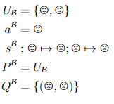

Is a model (mike hopefully will upload pic l8r)kv

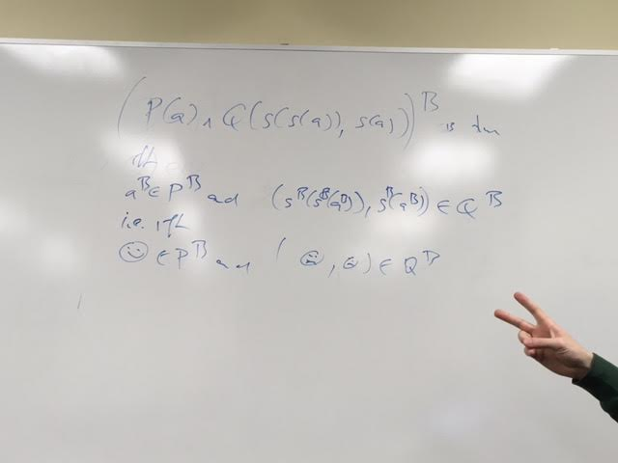



From example:



iff

( y, s(x) ) ∈ QB AND y ∈ PB AND s(x) ∈ PB

I.e. iff

Incorrect but it was our best try: ( ( 🌝 *OR* 😞) **AND** (😞)) ∈ QB **AND** (🌝 *OR* 😞 ) ∈ PB **AND** 😞 ∈ PB

